Dylan Lozon

ECE 101-02 MATLAB and C Programming

Mr. Watchorn

May 16, 2023

Mr. Watchorn,

Executive Summary

Here’s that stopwatch code you asked for. CTRL will stop and start the timer, while B will give you the current time. Right now it just runs in the terminal, but it wouldn’t be hard at all to deploy it to a physical timer if that’s what you want.

Discussion

The only two inclusions are stdio.h and windows.h. Stdio is primarily used here to print to the console, while windows.h allows me to use the windows API to monitor keypresses. Of course, keypresses will need to be handled differently if you’re not running windows.

I made sure to prompt the user every time they can start the timer, but not while the timer is running. This ensures the user can always tell at a glance whether the program is running or waiting. I also chose not to clear the console at any point, for largely the same reason.  
  
I also made the decision to make the B button non-functional if the timer was inactive. This prevents the timer from giving output when it is inactive.

Outcomes

Everything works as expected. A sample output has been provided in Figure 1. The inputs used to achieve Figure 1 were: CTRL, B, B, CTRL, B, B, CTRL, CTRL, ESCAPE.

Conclusions

This could be useful for anything that requires timing. In particular, I don’t think it would be hard to make this asynchronous and automatic, so that you can time how long it takes for a program to execute. Let me know if such a change would be useful.

Best,

Dylan

FIGURE 1:

FIGURE 2:

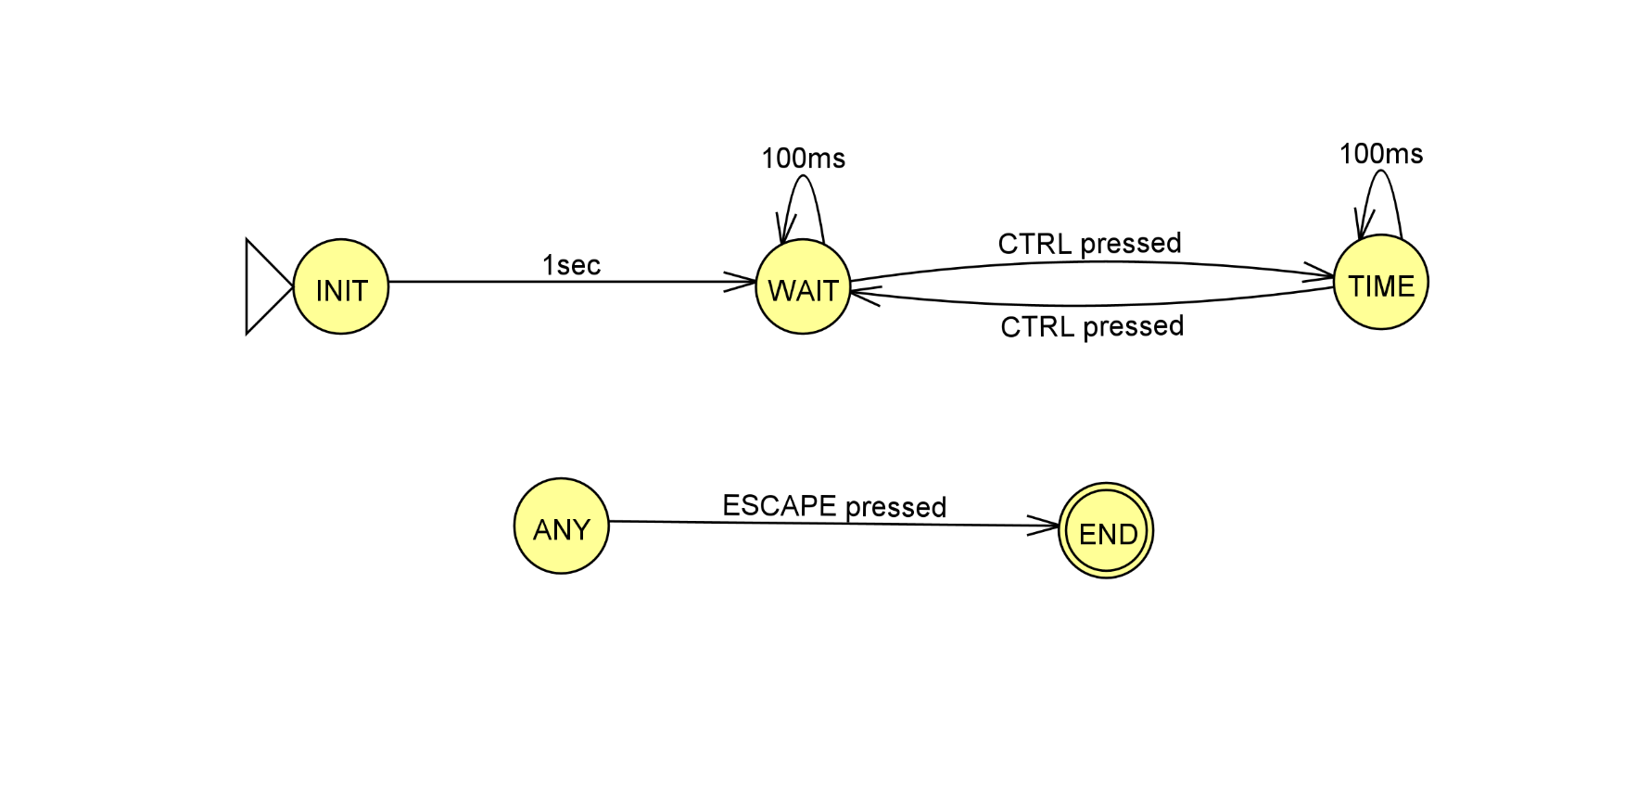

ANY is a collection of every state in the machine. Therefore, END can be reached from any other state.

There is no state that corresponds to the B button being pressed. This is because, for all practical purposes, B does not actually move the program to a different state, it simply performs a single action. It is worth noting, however, that the B button can only be pressed from the TIME state.